POSTGRE SQL SERVER IN AZURE

Step1:

Open azure portal and Search for PostgreSQL server.

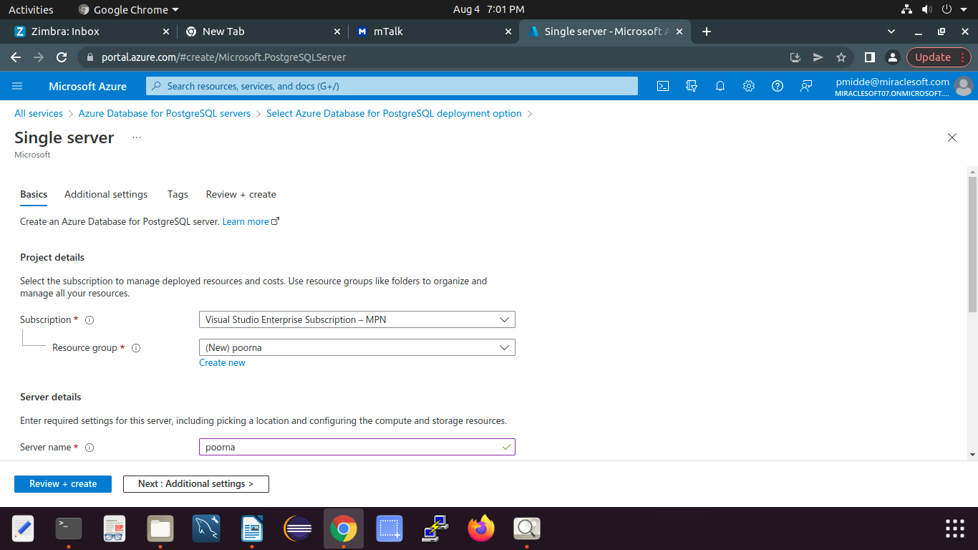

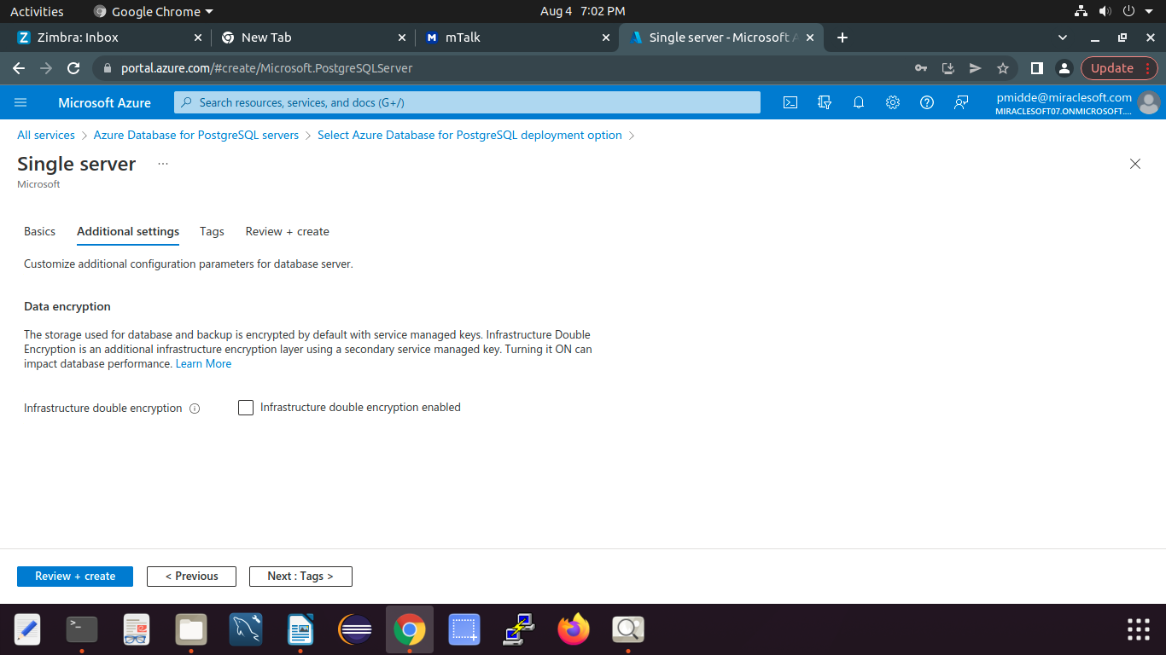
2.Complete all the neccessary fields.

3.Add tags if you want .

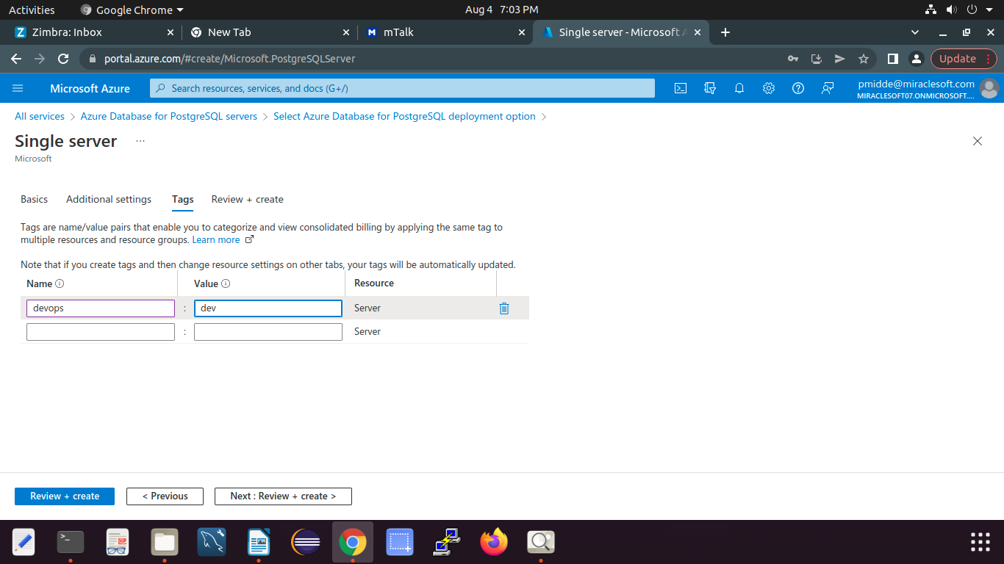
4.Review and Create the server.

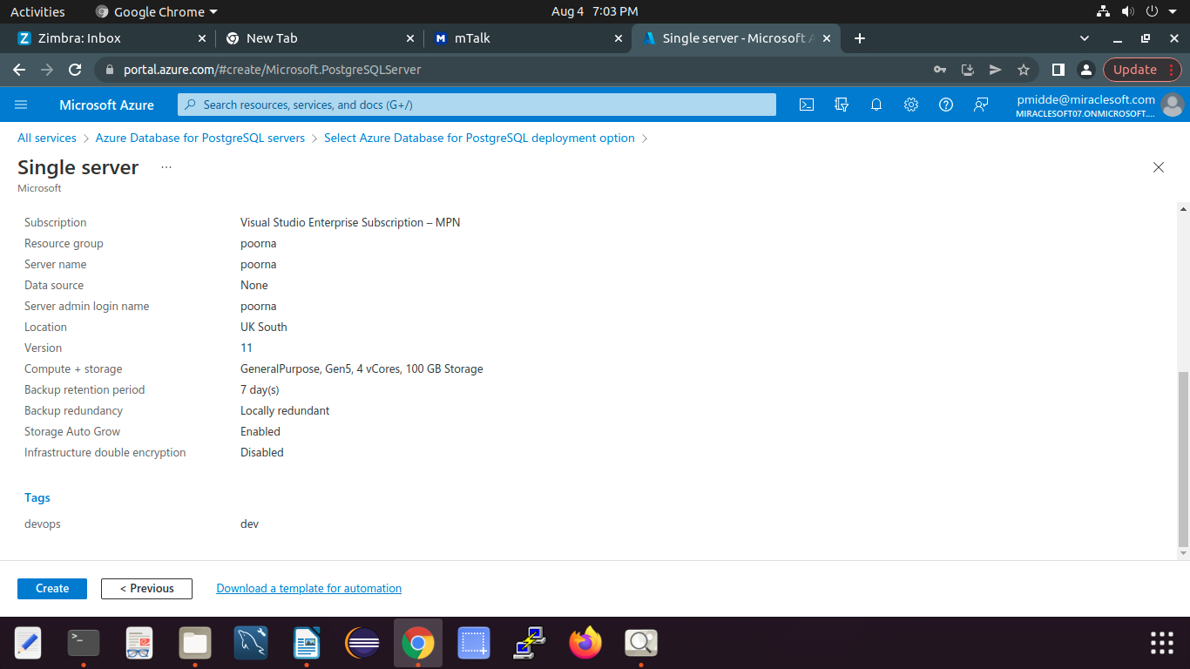

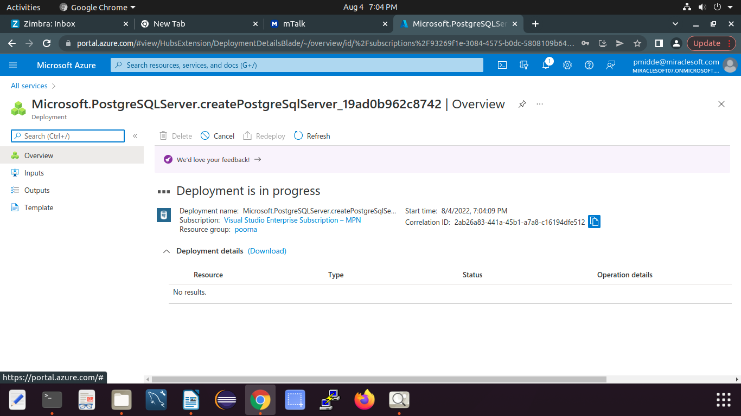

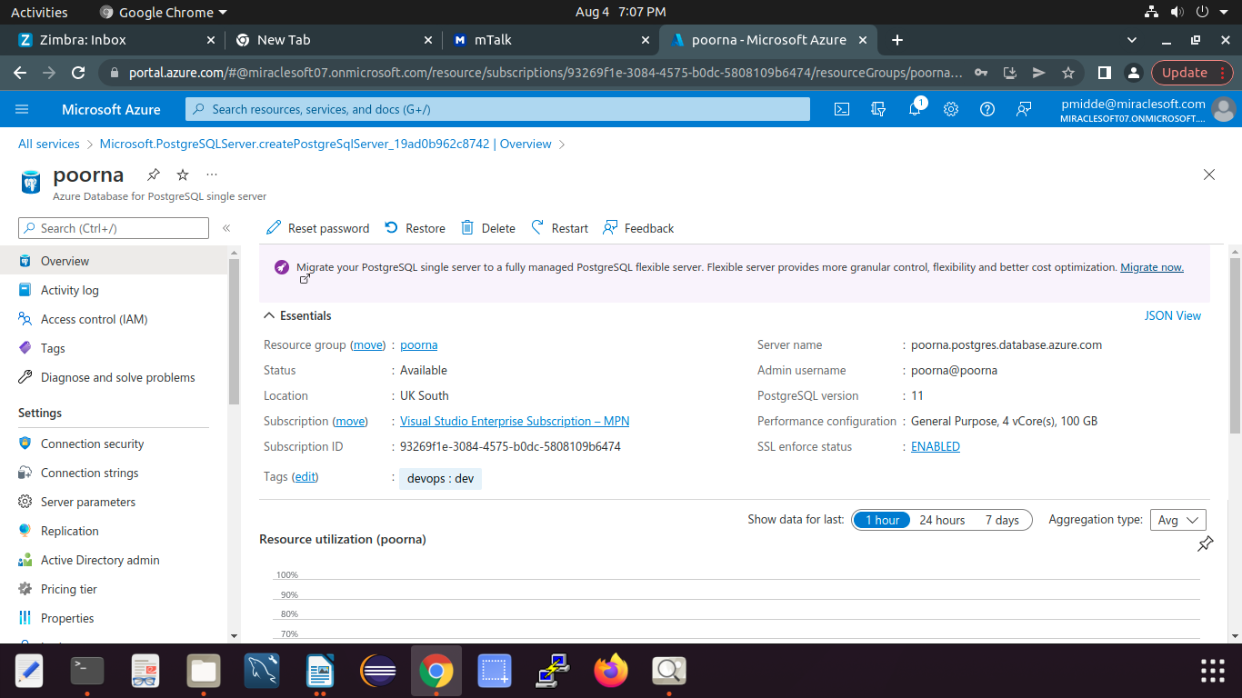
5.The Sql server is Created.

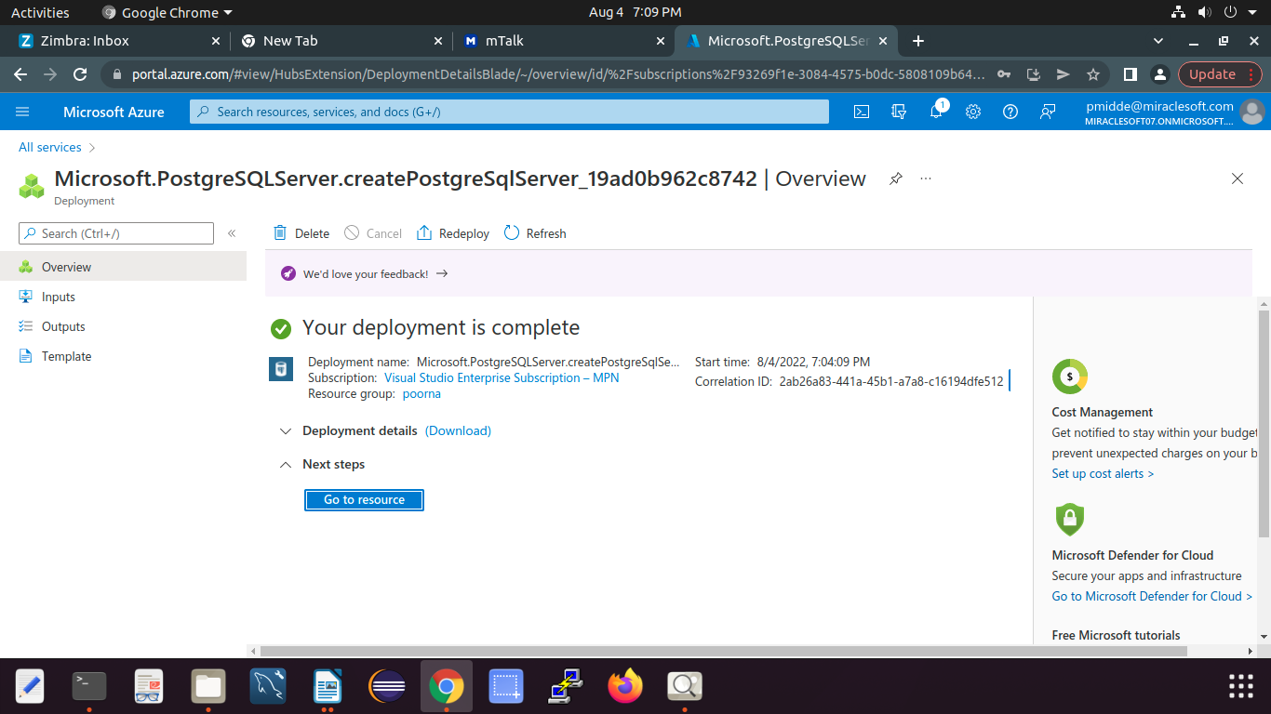
6.Delete the resource group after completing your work on it.

7.Create a Table in Mysql work bench.

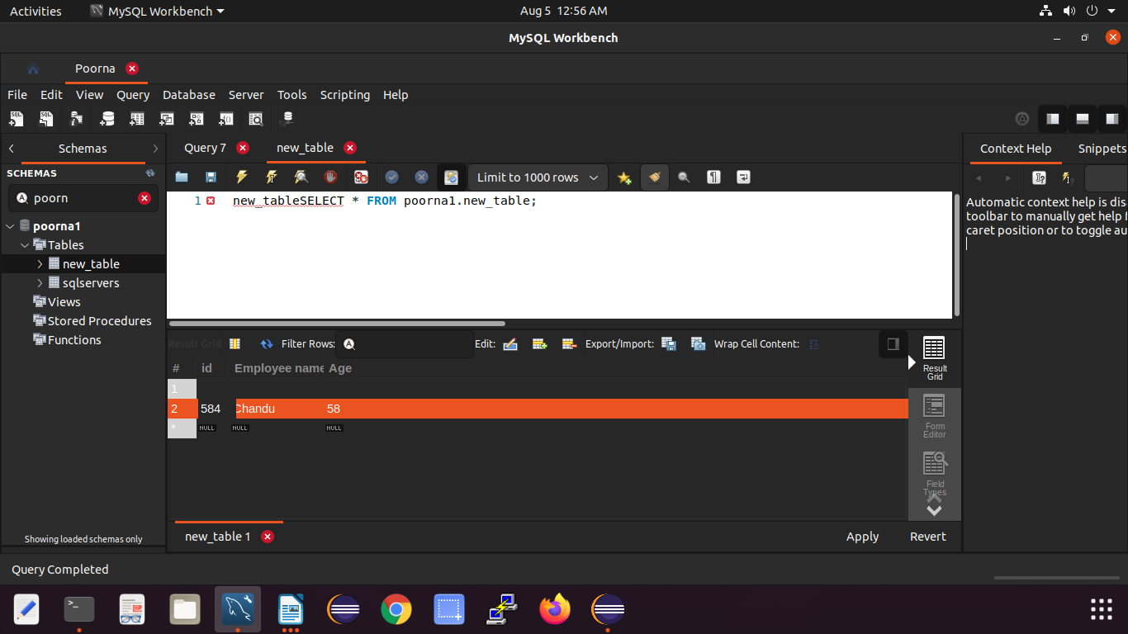

THANK YOU.

